**Exponents and Powers**

**EXPONENTS AND POWERS**

MATHS

1. Large numbers can be written in shorter form using exponents. For example: 1000 = 103

Here, 103 is called the exponential form of 1000.

10 (the number that is being multiplied) is called the base.

3 (number of times the same number is multiplied by itself) is called the power (or index or exponent)

1. As the exponent increases by 1 the value becomes ten times the previous value.
2. As the exponent decreases by 1 the value becomes 1 th the previous value.

10

1. For any non-zero integer ‘a’, am 

1 , where m is a natural number.

am

 a m

1. For a and b non-zero rational numbers, then  b 

 b m

  a 

, where m is a natural number.

   

1. **Laws of exponents**: If 'a' and 'b' are rational numbers different from zero and if x, y are positive integers, then
   1. ax  ay = ax+y
   2. ax 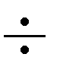 ay = ax – y
   3. (ax)y = axy
   4. (ab)x = ax  bx v.

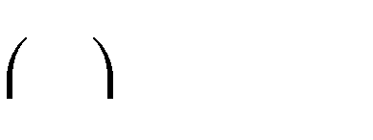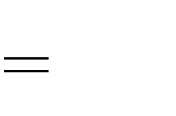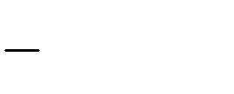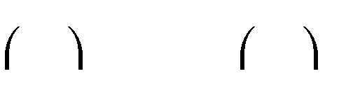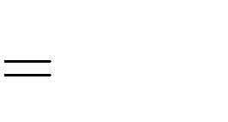

a x

b

a b

ax bx

x b x

a

vi.

1. a0 = 1
2. (-1)odd number = -1 (-1) even number = 1
3. **Exponential Equation**: An equation which has an unknown quantity as an exponent is called an exponential equation.

Example: i. 5x ii. 33x

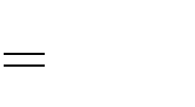

625

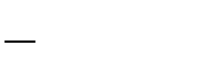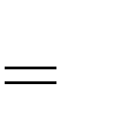

15

1

1. A number is said to be in standard form (or scientific notation) if it can be written as (k 10n), where k is real number such that 1 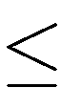 k < 10, and n is a positive integer.

Example:

i. 160000 = (1.6 105)

ii. 1548000 = (1.548 106)

iii. 0.0016 = (1.6 10-3)

1. To write very small numbers in standard form:
2. Get the number first and check if it lies between 1 and 10 or less than 1.
3. When the number is between 1 and 10, then write it as a product of the number itself and 100.
4. When the number is less than 1, then shift the decimal point to the right such that there is only one digit on the left side of the decimal point. Now write the given number as the product of the number so obtained and 10-n, where n is the number of places the decimal point has been shifted to the right. Thus, the final number so obtained is the standard form of the given number.